GlassBoxAI — Transparent Resume & Cover Letter Assistant
TagLine: Explainable AI decisions with ethical transparency
Positioning Statement:
GlassBoxAI helps users generate resumes and cover letters while showing exactly how the AI arrived at its output.
Unlike typical AI tools, GlassBoxAI:
- Logs prompts and outputs
- Allows users to compare revisions
- Makes AI usage auditable and explainable
- Gives users control over what data is stored
This framing alone separates you from 90% of “AI projects.”

Visual Identity (Initial Direction)
- Color palette: glassy blues, soft grays, subtle gold accents
- UI tone: clean, minimal, “audit-friendly”
- Design metaphors: transparency, layers, panels, diff views

Core User Flow (MVP)
- User signs in
- User uploads or pastes:
  - Resume
  - Job description
- User selects:
  - Resume improvement or
  - Cover letter generation
- AI generates content
- User sees:
  - Final output
  - Prompt used
  - Revision history
  - Transparency notice
- User can:
  - Edit manually
  - Regenerate
  - Export
  - Delete data

System Architecture (Balanced Frontend + Backend)

Frontend (What They See)
Tech: Next.js + TypeScript
Pages
- /login
- /dashboard
- /resume
- /cover-letter
- /history
- /privacy
Key UI Components
- Side-by-side diff viewer (original vs AI)
- Prompt transparency panel
- “Why this suggestion?” tooltip
- Data control toggles

Backend (Where You Shine)
Tech: Supabase (Postgres + Auth + Edge Functions)
You will explicitly own:
- Auth flows
- Data modeling
- Security (RLS)
- Serverless logic
- AI request handling
Database Schema
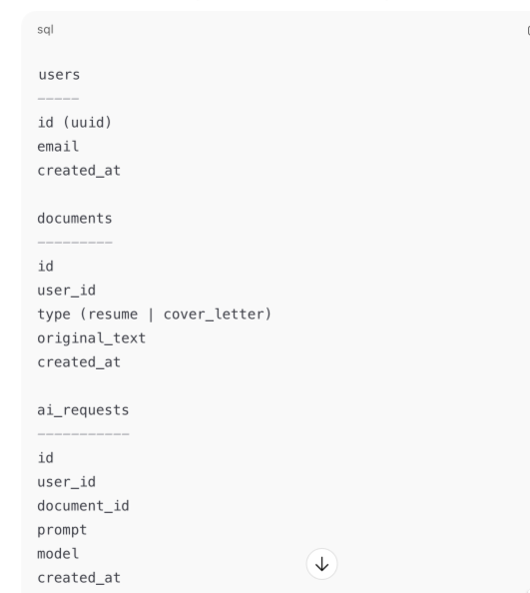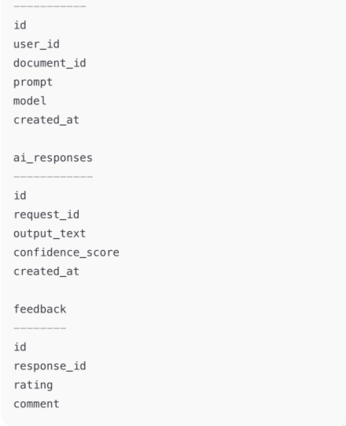
Backend Logic (Supabase Edge Functions)
Example: POST /generate-cover-letter
1. Authenticate user
2. Validate document ownership
3. Construct transparent prompt
4. Call LLM API
5. Store prompt + output
6. Return response to UI
You’ll also implement:
- Rate limiting
- Token usage tracking
- Optional anonymization
This is cloud-native backend work, not frontend fluff.

Ethical Design Features (Your Differentiator)
✔ AI disclosure banner
✔ Prompt visibility
✔ Revision history
✔ Delete/export user data
✔ “AI suggestions may reflect bias” notice
In interviews, this becomes:
“I designed GlassBoxAI to align with responsible AI principles.”

Folder Structure
glassboxai/
├── app/
│ ├── dashboard/
│ │ ├── page.tsx
│ │ └── DecisionSummary.tsx
│ ├── resume/
│ │ ├── page.tsx
│ │ └── ResumeForm.tsx
│ ├── cover-letter/
│ │ └── page.tsx
│ ├── history/
│ │ └── page.tsx
│ └── layout.tsx
│
├── components/
│ ├── ui/ # Generic UI (buttons, cards, modals)
│ ├── ai/ # AI-specific visualizations
│ │ ├── ConfidenceMeter.tsx
│ │ ├── FeatureImportance.tsx
│ │ └── ExplanationPanel.tsx
│ ├── ethics/ # Ethics + transparency UI
│ │ ├── BiasAlert.tsx
│ │ ├── RiskBadge.tsx
│ │ └── EthicsBreakdown.tsx
│ └── layout/ # Nav, footer, shell
│
├── lib/
│ ├── supabase.ts # Supabase client
│ ├── auth.ts # Auth helpers
│ ├── llm.ts # LLM wrapper
│ ├── explainability.ts # Explanation logic
│ ├── ethics.ts # Bias + fairness checks
│ └── audit.ts # Logging + traceability
│
├── supabase/
│ ├── migrations/
│ └── functions/
│ ├── analyze.ts # Main AI pipeline
│ └── audit-log.ts # Write audit trail
│
├── types/
│ ├── ai.ts
│ ├── ethics.ts
│ └── database.ts
│
├── docs/
│ ├── architecture.md
│ ├── ethics-framework.md
│ └── api.md
│
├── .env.example
├── README.md
└── package.json

If a recruiter asks:
“Why VS Code?”
You can confidently say:
“GlassBoxAI is a cloud-native, TypeScript-first application using serverless functions and PostgreSQL. VS Code provides the best tooling for rapid iteration across frontend, backend, and infrastructure in a single workspace.”

